Convolutional Neural Networks using
iPhone Images for Eyewear Classification

Juan Delgado
Syracuse University – Syracuse, NY
IST 691 – Deep Learning in Practice
jdelga02@syr.edu

Abstract
Image-based product classification in the fashion industry is challenging due to large numbers of visually similar styles and limited labeled data, particularly in real-world sales environments. This study evaluates the feasibility of using convolutional neural networks (CNNs) and transfer learning to classify eyewear products from iPhone images captured under variable lighting, background, and viewing conditions. A dataset of 420 images representing six eyewear SKUs was collected and used to train multiple models, including a CNN trained from scratch, MobileNetV2 with transfer learning and fine-tuning, and hierarchical CNN (HCNN) architectures based on VGG16 and VGG19 transfer learning. For the latter, models were evaluated at three hierarchical levels: brand, product type, and specific SKU. Results show that the scratch CNN failed to generalize, while transfer learning significantly improved performance. The VGG16-based HCNN achieved the best balance of accuracy and stability, reaching approximately 85% validation accuracy at the SKU level. These findings demonstrate the effectiveness of hierarchical transfer learning for real-world eyewear classification and support its potential use in mobile sales applications.

Introduction
Image data can be very extensive depending on the field of business. The fashion industry is a prime example, due to the many different categories available for articles of clothing, leading to a vast number of classes for classification problems. This creates a challenge for optimizing product flow and profitability across the supply chain of fashion products. For example, online apparel shops utilize image classification to manage their products faster and more effectively, such as product filtering and searching by brands, style and types. Moreover, it can be used to tag description of the products or make recommendations of similar product in which the user might be interested, [1]. In these types of scenarios computer vision a great option, by utilizing Deep Learning neural network methods to gain insight. Deep Neural Networks (DNN) such as Convolutional Neural Networks (CNN) are proven to work well with large amounts of unstructured image data.
In this project we will focus on image data of eyewear fashion pieces. Since I work at an eyewear fashion manufacturer, I wanted to apply my learnings of CNNs into a real-world context problem. My goal as a data driven sales professional is to identify strategies and tools to bridge the gap between business development teams and analytics teams, so the question arises, how can computer vision through CNNs help sales representatives in the field? Sales representatives are constantly challenged with meeting sales quotas and Key Performing Indicators (KPIs) through actionable results, so how can we help them be more efficient in their everyday tasks?
The answer is in the application of recognizing and classifying images in fashion products using machine learning and deep learning methods. One of the key advantages is enhancing user experience that will affect business KPIs, which can be shown in time spent on browsing, the volume of purchase, and the average check out value. By adopting CNN in fashion e-commerce, users can be served with fast and convenient product search and automatic product recommendation. [2]
However, when it comes to fashion product classification there are some key problems that follow this product category. First, there is a vast number of styles and SKUs. Managing all this product can quickly become overwhelming, which can hinder the effectiveness and profitability of sales interactions. For example, eyewear sales representatives visit their customers and need to take inventory of the product on the shelf, to evaluate what has sold, what has not sold, and what else needs to be purchased to maximize profitability. Second, classes of fashion products can have similar characteristics, and they can look very different based on aspect ratio and angle of the image, [3].
In this research paper we explore product image classification through images taken on an iPhone, to help sales representatives be more efficient in sales interactions. The goal of this project is to experiment with real world eyewear iPhone image data and evaluate the feasibility to train a CNN model to recognize a specific product SKU. The long-term goal of this project is to use our findings to create scalable image recognition mobile applications for sales representatives in the eyewear fashion industry. To do so we will create multiple models using traditional CNNs and Transfer Learning techniques.

Literature Review
As part of our research, we started by looking for similar deep learning projects within the fashion industry. While there has been research in the fashion classification category, most of it uses the MNIST fashion dataset [1][6], or images from e-commerce databases [3][2]. This leads us to believe that fashion image classification with real-world iPhone image data is a more novel area of research. When it comes to CNNs and transfer learning, there is significant research for the use of MobileNet and VGG, among other well-known algorithms. Therefore, we looked for research that used specifically MobileNetV2, VGG16 and VGG19 for transfer learning, [4][5]. The article by Seo and Shin (2019) [1] was of special interest for this project, since it introduced their own novel approach for improved fashion product classification by using a hierarchical CNN model (HCNN), then using transfer learning using VGG16 and VGG19.

Data Acquisition
Since our goal is to correctly classify a specific SKU from a picture taken by a sales representative in the field, we needed image data that simulated that real life interaction. For our data acquisition, we took images of 6 different SKUs (classes) to identify and classify. Using an iPhone we took 70 pictures per SKU class, with a variety of backgrounds, lighting levels and angles. These training pictures were taken at my home, so I chose 7 locations in my house, and took 10 pictures at each location for each class. Each piece of eyewear was held from the far temple and was angled to the camera in a 45-degree angle. Eyewear fashion pieces have key distinctions on their front and side temple – in terms of shape, design and color – so the best way to see all these features is through a 45-degree image. This is standard for the industry and is easy for our sales representatives to provide for future experimentation. See example below from our eyewear e-commerce database displaying SKU GG0062S – 003 in a 45-degree angle shot, on Image 2. We can compare this to one of the images we took with an iPhone, with the attempt to replicate a similar real-life result, on Image 1. For every image taken, I shifted the piece of eyewear slightly to show different features and angles of the SKU, and I turned to face a different spot of the room to introduce background variety to the image data.
Image 1 – Example from dataset

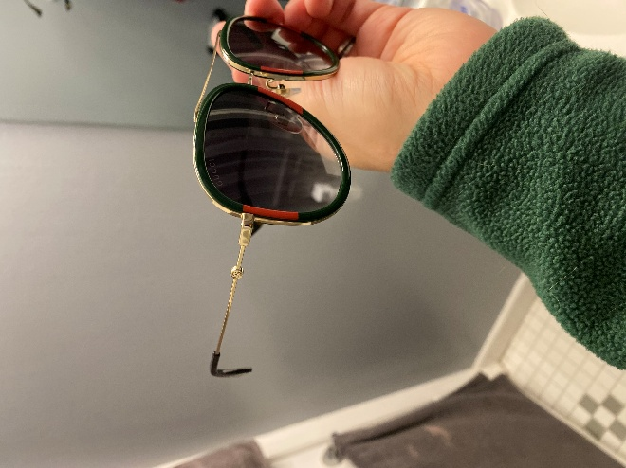
Image 2 – example from e-commerce database
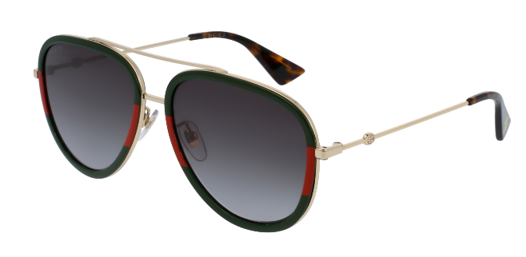

Methodology
This research paper employs a supervised deep learning approach to image classification using standard Convolutional Neural Networks (CNNs) and Transfer Learning methods. Traditional Artificial Neural Networks (ANNs) often fail to recognize the same feature that appears at a different position in training images, but CNNs are trained to identify features irrespective of their position on the image. By using a series of convolution steps, the image is broken into a series of overlapping image tiles, done by passing a sliding window (filter) over the image. The output array of this convolution is down sampled using max pooling or average pooling, which selects the maximum or average value from each sub-region, which helps in dimensionality reduction. After the image is sufficiently reduced, then it is fed into a fully connected neural network to decide on the presence of key features, [3]. This process effectively creates a feature extraction map, which is used to produce image classification.
This project will be primarily experimental, to test the feasibility of using real iPhone image data from a sales environment with a CNN classification model. However, one key problem with eyewear fashion image data, is the vast number of SKU (classes) to be identified and classified. In tandem with the rest of the fashion industry, my company has several new releases each year to show the latest fashion trends. This constant new introduction of SKUs (classes) would require a very robust CNN model and data acquisition strategy to keep up with demand. Thus, our research methodology is to start by experimenting with CNN models built from scratch, then transition to experiment with more robust Transfer Learning, which uses pretrained deep learning models to enhance training and classification performance.
We will use two Transfer learning algorithms, MobileNetV2 and VGG-HCNN. MobileNetV2, is a lightweight deep convolutional neural network (CNN), that is widely used for transfer learning in image classification tasks due to its efficiency in mobile and embedded applications, [4]. Each block follows a sequence: an expansion layer, which scales up the input dimension; a depth wise convolution, which reduces spatial dimensions while maintaining depth; and a projection layer (linear bottleneck), which compresses features into a lower dimensionality space, [5]. Since our long-term goal is to develop mobile applications for sales representatives in the field, MobileNetV2 was a perfect option to implement transfer learning methods. We decided to use the majority of MobileNetV2 as the backbone of the training, then first by unfreezing 40 layers, then by unfreezing the last 20 layers of the model, and training the rest on our eyewear fashion dataset. The earlier layers of the model are used to identify high level features and patterns, while the later layers are used to identify fine features that help with final classification. Due to the small size of our dataset, we also decided to implement early stopping on the training to prevent overfitting.
The second transfer learning method implements the VGG16 and VGG19 with a Hierarchical Convolutional Neural Network (HCNN) structure. VGG doubles the number of filters after each pooling layer, which shrinks spatial dimensions while growing its depth. In other words, as a result of the convolutional and pooling layers, the spatial size of the input volume at each layer will decrease, and the depth of the volume will increase due to the increased number of filters. This is all while using ReLU for non-linearity activation function and is trained using stochastic gradient descent, [1]. While VGG is already a robust algorithm there are inherent issues with fashion data classification, mainly due to the vast number of classes to be identified. This leads to hindered classification accuracy because fashion product classes tend to be very similar yet belong to different product categories. Thee VGG-HCNN introduces a Hierarchy structure by separating classes that are completely different in the first place into hierarchy subcategories, which helps to improve classification accuracy among very similar classes, [1]. By adapting the code from Seo and Shin (2019), we tested the Hierarchy CNN architecture to see if we would obtain improved classification results on our eyewear fashion data. First the images would be classified as part of a specific brand, second, they would be classified as being either sun or optical, then finally as the specific SKU. This is done using transfer learning with both VGG16 and VGG19.

Results
We started with a standard CNN model built from scratch, using 3 convolution layers and Max Pooling layers, with the ReLU activation function at each layer. During the flattening layer we used the Softmax activation function. Then for the model we used the ‘Adam optimizer’ along with the ‘sparse categorical crossentropy’ loss function and obtained the following classification results (Table 1): training accuracy of 0.1941, validation accuracy of 0.1436 and loss of 1.7941. The extremely low training accuracy means the model did not learn discriminative features of the data, followed by very low validation accuracy and high loss, the model is essentially random guessing. The main reason this could be happening is due to our small dataset, so we moved onto transfer learning methods for better results.
When we implemented transfer learning using MobileNetV2, we unfroze the last 40 layers and saw the following results (Table 1): Training accuracy of 0.2201, validation accuracy of 0.1905 and validation loss of 1.9528. These results show partial learning, but the model is still stalling. Since the validation accuracy plateaus immediately at 0.1905, the model is likely predicting the same class for most validation samples. Unlike the previous CNN from scratch, this model is learning something, but not enough to generalize results.
Since we did not get satisfactory results from our first attempt with transfer learning, we went back a step and froze all the layers along with some fine-tuning. The results were as follows (Table 1): Training Accuracy of 0.7238, validation accuracy of 0.8973 and validation loss of 0.5371. Evaluating these results, this is the first model that is learning well and classifying accurately, showing a successful transfer learning-baseline for our data. The fine tuning was as follows: First, we adjusted the learning rate from 1e-5 to 1e-3 because it was far too small. Second, we changed the Max Pooling to Global Average Pooling. This helps with shape identification, which is especially important for eyewear shape recognition. Third, we reduced the classifier complexity from 256 to 128 dense layers, and dropout of 0.4 to 0.3. With 256 dense layers we end up with millions of parameters, whereas with 128 dense layers we end up with around 165k parameters. Since we have a smaller dataset, having less parameters allows the model to clearly notice the 6 different classes.
Table 1
 |  | MobileNetV2
Metrics | Base Model | 1st Model | 2nd Model | 3rd  Model
Training Accuracy | 0.1941 | 0.2201 | 0.7238 | 0.7909
Validation Accuracy | 0.1436 | 0.1905 | 0.8973 | 0.8817
Validation Loss | 1.7941 | 1.9528 | 0.5371 | 0.4684

For the final test in MobileNetV2 Transfer Learning, we unfroze and retrained the last 20 layers of the model. Our results were as follows (Table 1): Training Accuracy of 0.7909, Validation Accuracy of 0.8817 and Validation Loss of 0.4684. These results were very similar to the last model, which means we did not break the performance of the model, while training it further on our own images. This halfway point between the previous models produced small but real improvement in loss, with accuracy essentially unchanged. We stopped at this stage and plotted a chart showing some of the correct validation examples (Chart 1), proving that CNN model

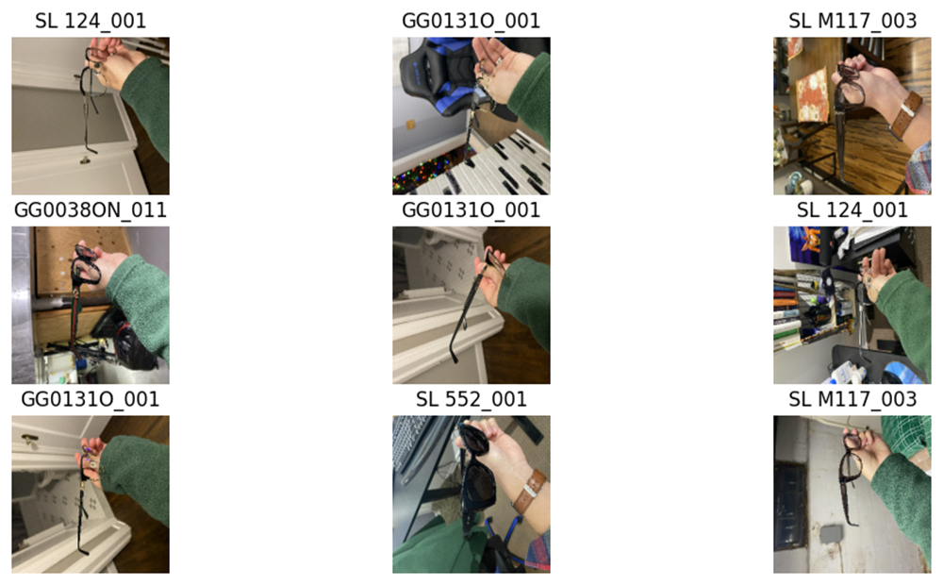
Chart 1 – Correct Validation Examples from MobileNetV2 3rd Mode

training and classification is possible on real world iPhone images of eyewear fashion pieces.
Next, we looked onto Transfer Learning using the VGG-HCNN architecture from Seo and Shin (2019). We built our first hierarchical model without VGG transfer learning, so we could get a good baseline for improvement. Then we implemented transfer learning with both VGG16 and VGG19. Each model would first predict Brand as C1, then Type (Optical or Sun) as C2 and finally the SKU as the Fine level prediction. The results were as shown on Table 2 and Table 3. First, we can see significant improvement in both training and validation metrics from the base HCNN model to both the VGG16 and VGG19 models. In the Base HCNN model, the hierarchy is not really learning any meaningful discrimination between classes at any level. C1 training accuracy is 0.4524 and training accuracy is 0.4762, C2 training and validation accuracy
are both 0.3333, fine training accuracy is 0.1756 and validation accuracy is 0.1310, and lastly training loss is 1.4350 and validation loss is 1.4374. The low accuracy at all levels well below 50% shows that the model is not really learning any meaningful visual discrimination between classes, and is essentially randomly guessing classes, which is likely due to the small dataset that we have available.
When we implement VGG16 into to the HCNN model the metrics improve drastically. The model learned extremely well from the training data at close to 100% learning, with C1 training accuracy at 0.9851, C2 training accuracy at 0.9821 and Fine training accuracy at 0.9970, with overall loss of 0.0454. The validation results were also very high, with C1 validation accuracy at 0.8517, C2 validation accuracy at 0.8571, fine validation accuracy at 0.8452, and validation loss of 0.8452. Although this was our expected output since with transfer learning from the VGG16 model, that has millions of pretrained parameters that are useful for feature discrimination, we were happy to see the high accuracy results. This also shows that the ImageNet Data that VGG16 is trained on is proven to be useful in classifying real world iPhone eyewear images.
Table 2 – Training Metrics
Training Metrics | Base HCNN | VGG16 HCNN | VGG19 HCNN
Overall Loss | 1.4350 | 0.0454 | 0.0933
C1 Accuracy | 0.4524 | 0.9851 | 0.9315
C2 Accuracy | 0.3333 | 0.9821 | 0.9524
Fine Accuracy | 0.1756 | 0.9970 | 0.9702

Table 3 – Validation Metrics
Validation Metrics | Base HCNN | VGG16 HCNN | VGG19 HCNN
Overall Loss | 1.4374 | 0.4132 | 0.4688
C1 Accuracy | 0.4762 | 0.8571 | 0.8452
C2 Accuracy | 0.3333 | 0.8571 | 0.8214
Fine Accuracy | 0.1310 | 0.8452 | 0.8452

We also implemented VGG19 to see if we would get better results, but it ended up performing slightly worse and less stably than VGG16 for our given task. This means that the extra depth of VGG19 does not add useful discriminative power for fine grained accuracy results. This is likely related to the data size and type of fashion article. Since eyewear has a very unique shape and few micro patterns, the additional convolutional layers from VGG19 are simply not adding more classification capacity or benefit.
In conclusion, the VGG16-HCNN model performed very similar to the MobileNetV2 2nd and 3rd models. While there were small differences in the validation metrics, both methods of Transfer Learning have proven capable of properly classifying real world iPhone images of eyewear fashion products. VGG16-HCNN had a fine level accuracy of 0.8452, while the MobileNetV2 had validation accuracy of 0.8973 for the 2nd model and 0.8817 for the 3rd model. The loss for VGG16-HCNN was 0.4132, while the MobileNetV2 has loss of 0.5371 for the 2nd model and 0.4684 for the 3rd model. The key difference between the MobileNetV2 models, is that the 2nd model uses all the pre-trained parameters of the algorithm, while the 3rd model has the last 20 layers unfrozen to be trained with our eyewear data. Since the VGG-HCNN has slightly higher validation accuracy, and the MobileNetV2 has slightly lower validation loss, these metrics end up balancing each other. In other words, with continued fine-tuning both methods of transfer learning offer a satisfactory base model for the classification task at hand.

Discussion
This study set out to evaluate the feasibility of applying convolutional neural networks to real-world eyewear image classification using photographs taken on an iPhone in a simulated sales environment. The primary objective was to determine whether modern CNN architectures and transfer learning techniques could reliably identify specific eyewear SKUs despite limited data availability, high visual similarity between products, and unconstrained imaging conditions such as variable lighting, backgrounds, and angles. The results provide several important insights into the effectiveness of CNN-based approaches for fashion product classification and their potential application in sales enablement tools for the field sales setting.

References
[1] Seo, Y., & Shin, K.-s. (2019). Hierarchical convolutional neural networks for fashion image classification. Expert Systems with Applications, 116, 328–339. https://doi.org/10.1016/j.eswa.2018.09.022
[2] Iliukovich-Strakovskaia, A., Tsvetkova, V., Dral, E., & Dral, A. (2018). Non-personalized fashion outfit recommendations: The problem of cold starts. In Á. Rocha et al. (Eds.), World Conference on Information Systems and Technologies (WorldCIST 2018) (Advances in Intelligent Systems and Computing, Vol. 747, pp. 41–52). Springer.
[3] Eshwar S G, Prabhu, G. G. J., Rishikesh, A. V., Charan, N. A., & Umadevi, U. V. (2016). Apparel classification using convolutional neural networks. IEEE.
[4] M. Sandler, A. Howard, M. Zhu, A. Zhmoginov, and L.-C. Chen, “MobileNetV2: Inverted residuals and linear bottlenecks,”in Proceedings of the IEEE Conference on Computer Vision and Pattern Recognition (CVPR), 2018, pp. 4510–4520.
[5] Pardeshi, R., Thinakaran, R., & Kharat, S. (2025). Automated dried fish classification using MobileNetV2 and transfer learning. International Journal of Advanced Computer Science and Applications (IJACSA), 16(7).
[6] Bhatnagar, S., Ghosal, D., & Kolekar, M. H. (2017). Classification of fashion article images using convolutional neural networks. Proceedings of the 4th International Conference on Image Information Processing (ICIIP), 357–362. IEEE.

